Nokuthula Ngcongo

CAPACITI

**System Check and Troubleshooting Report**

Course Name: *Technical Support Fundamentals*

*Date: 03 October 2025*

Introduction........................................... 2

Systems Specifications........................... 2

Simulated Issue and Resolution...............4

Conclusion..............................................6

**Introduction**

In this report, I will present the results of a basic system check and troubleshooting task. The task is completed on Windows. It includes recording system specifications, verifying the network status, simulating a basic issue, and resolving it.

**Systems Specifications**

* **Operating System:** Windows 11

**Screenshot:**

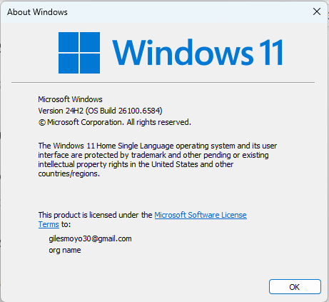

* **Processor:** 12th Gen Intel(R) Core (TM) i5-1235U (1.30 GHz)
* **RAM:** 8.00 GB (7.63 GB usable)

**Screenshot:** 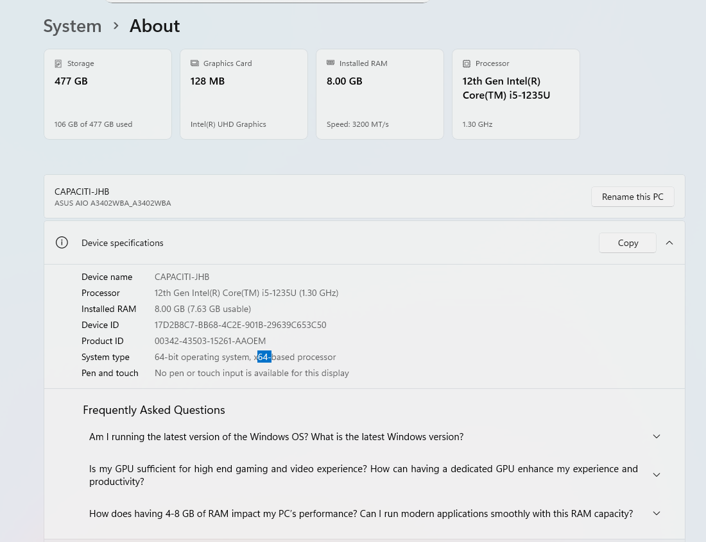

* **Storage: 368 GB free of 474 GB**

**Screenshot:**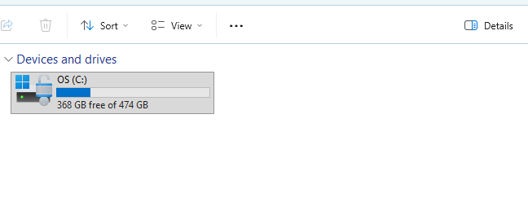

**Network Status:**

The network connection was checked to verify connectivity. Detailed screenshot is provided below:

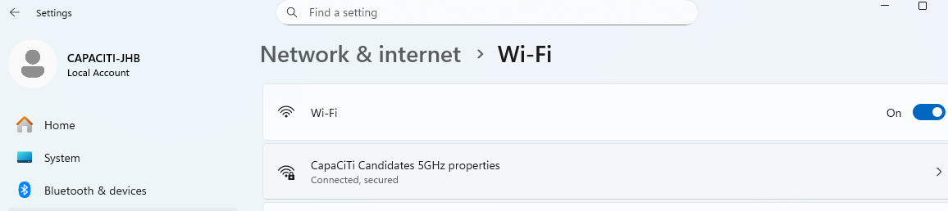

**Simulated Issue and Resolution**

* **Simulated Issue:** Screen resolution changed to a lower setting, making the display blurry.
* **Troubleshooting Steps:**

1. Opened Display settings from Desktop.
2. Noted the incorrect resolution.
3. Changed back to the recommended resolution.

* **Results:** Screen returned to normal clarity.

**Before (wrong resolution)**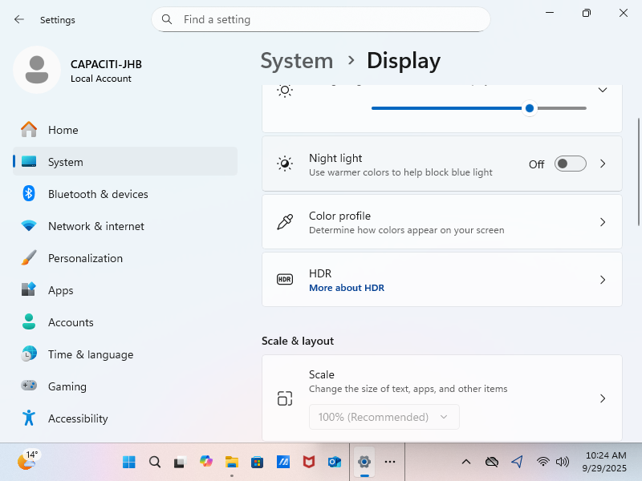

**After (fixed resolution)**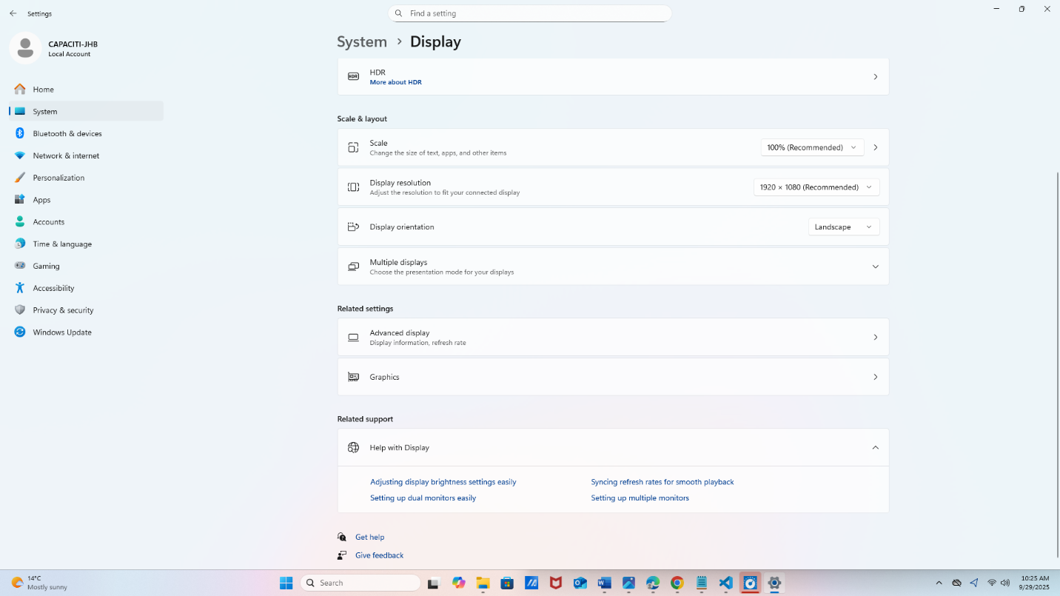

**Conclusion**

In this assignment, I performed a basic system check and troubleshooting task on a Windows system. I recorded the system specifications, verified the network status, and simulated a common issue by changing the screen resolution. By identifying the problem and restoring the recommended resolution, I demonstrated fundamental troubleshooting skills, including:

* Checking system information (OS, processor, RAM, storage)
* Verifying connectivity and system settings
* Diagnosing and resolving a simple display issue

This exercise provided practical experience in IT support tasks and reinforced the importance of methodical problem-solving and clear documentation for effective technical support.